Inclusive research is when people with disability are part of the research team.
INCLUSIVE RESEARCH
FACT SHEET

Inclusive research looks at issues that are important to us.

Inclusive research uses our life experience.

Working on research helps us build skills and speak up.

With inclusive research we all work together.

Everyone in the team helps make decisions.

Everyone is listened to and respected.

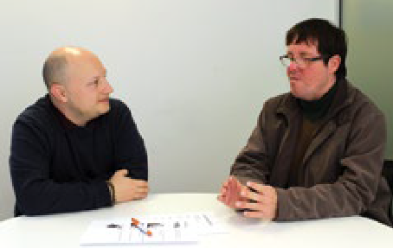
People with disability are valued.

People with disability are paid for their work.

2 INCLUSIVE RESEARCH: Fact Sheet

People with disability must be included from the start.

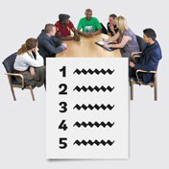Ask people what they need so that they can be included:
- Extra time.
- Support staff.
- Access.
- Travel needs.
- Information they can read.
- Training.

Meetings must include everyone:
- Not be too long.
- Have breaks.
- Time to get to know people.

INCLUSIVE RESEARCH: Fact Sheet 3

Inclusive research is good for:
- People with disability.
- Disability organisations.
- Universities.
- Community.

This fact sheet is a summary of Inclusive Research: A guide to doing research with people with disability
INCLUSIVE RESEARCH
A guide to doing research with people with disability

To look at the guide go to:
www.disabilityinnovation.unsw.edu.au

For more information: Phone: 02 9385 9114
Email: diiu@unsw.edu.au

4 INCLUSIVE RESEARCH: Fact Sheet

